**Mini-Project Report**

**Name – Swaraj Santosh Pawar**

**Employee ID – 5852**

**Mini-Project on Recipe Recommendation App**

**Problem Statement**

Cooking enthusiasts face challenges in finding personalized recipes due to information overload, lack of personalization, and issues like dietary restrictions and ingredient availability. Existing platforms often fail to deliver tailored suggestions, leading to frustration and time wastage. While making website we are using HTML, CSS & JAVASCRIPT.

**Understanding**

The Recipe Recommendation App aims to address common challenges faced by cooking enthusiasts, including information overload, lack of personalization, and difficulties related to dietary restrictions and ingredient availability. The proposed solution involves creating a user-friendly app with personalized features such as user profiles, smart filters, an ingredient scanner, and integration with calendars. By offering tailored recipe suggestions, the app seeks to simplify the cooking process and enhance the overall user experience, making it more enjoyable and efficient.

Top of Form

**Introduction**

Welcome to the Recipe Recommendation App, your go-to kitchen companion for easy and personalized cooking adventures! In a world filled with endless recipes online, figuring out what to cook can be a bit overwhelming. But fear not, because our app is here to make your cooking experience a breeze.

This app solves the common problems of too many choices, not-so-personal recommendations, and the confusion of dietary needs and ingredient availability. Picture this: a place where your taste preferences, dietary requirements, and the ingredients you have on hand all come together to suggest recipes designed just for you.

Whether you're a cooking pro looking for something fancy or someone in a hurry craving a quick and tasty meal, the Recipe Recommendation App has got you covered. With easy-to-use filters, custom recommendations, a nifty ingredient scanner, and a connection to your daily schedule, this app makes cooking stress-free and enjoyable.

Say goodbye to the recipe search struggle and hello to a simpler way of cooking with the Recipe Recommendation App. Let it be your guide in discovering tasty recipes that match your style, making your time in the kitchen a delight. Happy cooking!

**Why We Need Recipe Recommendation App**

In the bustling world of today, our lives are fast-paced, and time is a precious commodity. The Recipe Recommendation App addresses the pressing need for a simplified and personalized approach to cooking by providing tailored solutions to common culinary challenges. Here's why we need this app:

1. **Overwhelming Choices:** With the vast sea of online recipes, choosing what to cook can be a daunting task. The Recipe Recommendation App streamlines this process by offering personalized suggestions, saving users from information overload.
2. **Personalized Cooking Experience:** Everyone has unique taste preferences and dietary restrictions. The app caters to individual needs, ensuring that users receive recipe recommendations aligned with their culinary preferences and health requirements.
3. **Efficiency in Meal Planning:** Busy schedules often leave little time for meal planning. The app integrates with users' calendars, suggesting recipes that fit seamlessly into their daily routines and time constraints.
4. **Ingredient Utilization:** One common challenge is figuring out what to cook with the ingredients available at home. The app's ingredient scanner allows users to input what's in their kitchen, generating recipes that make the most of those ingredients.
5. **Dietary Consciousness:** As dietary awareness grows, users with specific dietary restrictions, such as vegetarian, vegan, or gluten-free preferences, need a reliable source for recipes that align with their lifestyle choices. The Recipe Recommendation App caters to diverse dietary needs.
6. **Community and Exploration:** The app fosters a sense of community by allowing users to rate and review recipes. This creates a vibrant space for culinary enthusiasts to share experiences and discover new and exciting recipes.

The app fosters a sense of community by allowing users to rate and review recipes. This creates a vibrant space for culinary enthusiasts to share experiences and discover new and exciting recipes.

**ALGORITHM**

1. **Define the Structure:**

* Create an HTML document outlining the structure of the webpage.
* Include sections for the header, navigation, main content area, About Us Section and footer.

1. **User Interface (UI) :**

* Create a main page with a search bar, to display recipes.
* Design a recipe details page to show ingredients, instructions, and other relevant information.

1. **Search Functionality:**

* Implement a search bar that allows users to enter keywords.
* Use JavaScript to capture user input and trigger a search function.
* Make an API request to a recipe database, passing the user's query as a parameter.

1. **Styling with CSS:**

* Implement a basic CSS stylesheet to style the website.
* Design the header, navigation bar, Recipe cards, and footer for a visually appealing layout.

1. **Header and Navigation:**

* Include a header with the website's title.
* Add a navigation bar with search box to search for recipes .

1. **Recipe Display:**

* Create a search bar to search Recipes.
* We use API to display recipes in card and pop-up box to display recipe ingredients and instructions.

1. **Dynamic Content Loading (JavaScript):**

* Use JavaScript to dynamically load course data onto the webpage.
* Fetch recipe information(Name, type of recipe , Category of recipe), recipe ingredients, recipe instructions from a predefined data source or an API.
* Populate the course section with dynamically generated content.
* To show recipe ingredients and instructions using pop-up box.

1. **Enrolment Functionality:**

* Implement a function in JavaScript to display recipe information using cards from API and its Ingredients and Instructions using pop-up box.

1. **Responsiveness:**

* Ensure the website is responsive to different screen sizes and devices using media queries in CSS.
* Optimize the layout for both desktop and mobile users.

1. **Footer:**

* Design a footer with relevant information, such as copyright details or social media links to additional resources.

1. **Testing :**

* Test the website on various browsers to ensure cross-browser compatibility.
* Verify that the website is functional and user-friendly on different devices.

1. **Optimization:**

* Optimize the website for performance, considering factors such as image compression and code minification.

1. **Deployment:**

* Deploy the website on a web server or hosting platform to make it accessible to users.

This algorithmic outline provides a step-by-step guide for creating a Recipe Recommendation website. Depending on the specific requirements, additional features and considerations may be necessary for a fully functional and secure platform.

**HTML CODE**

**Index.html**

<!DOCTYPE html>

<html lang="en">

<head>

    <meta charset="UTF-8">

    <meta name="viewport" content="width=device-width, initial-scale=1.0">

    <title>Mumma’s Kitchen</title>

    <link rel="stylesheet" href="style.css">

    <script src="https://kit.fontawesome.com/c1f28cf387.js" crossorigin="anonymous"></script>

     <script src="https://cdn.jsdelivr.net/npm/@popperjs/core@2.11.8/dist/umd/popper.min.js" integrity="sha384-I7E8VVD/ismYTF4hNIPjVp/Zjvgyol6VFvRkX/vR+Vc4jQkC+hVqc2pM8ODewa9r" crossorigin="anonymous"></script>

     <script src="https://cdn.jsdelivr.net/npm/bootstrap@5.3.2/dist/js/bootstrap.min.js" integrity="sha384-BBtl+eGJRgqQAUMxJ7pMwbEyER4l1g+O15P+16Ep7Q9Q+zqX6gSbd85u4mG4QzX+" crossorigin="anonymous"></script>

    <link rel="stylesheet"

     href="https://cdnjs.cloudflare.com/ajax/libs/font-awesome/6.5.1/css/all.min.css"

    integrity="sha512-DTOQO9RWCH3ppGqcWaEA1BIZOC6xxalwEsw9c2QQeAIftl+Vegovlnee1c9QX4TctnWMn13TZye+giMm8e2LwA=="

    crossorigin="anonymous"

    referrerpolicy="no-referrer" />

</head>

<body>

      <header> <!--Thss is used for heading and Navigation Bar-->

        <nav>

            <h1>Mumma's Kitchen</h1>

            <form>

                <input type="text"

                 placeholder="Search for Recipes..."

                 class="searchBox">

                 <button type="submit" class="searchbtn">Search</button>

            </form>

        </nav>

      </header>

      <main>

        <section>

            <div class="recipe-container">

            <h2>Search your favourite Recipes...</h2>

          </div>

          <div class="recipe-details">

            <button type="button" class="recipe-close-btn">

              <i class="fas fa-times"></i>

            </button>

            <div class="recipe-details-content"></div>

          </div>

        </section>

      </main>

      <!---Hero-->

      <img src="Images/Hero.jpg" width="100%" height="80%">

      <!----->

      <!---About Us-->

      <div class="about-msg">

        <h2>About Us</h2>

        <p>Welcome to Mumma's Recipe, where culinary innovation meets personalized delight!

          We are more than just a Recipe Recommendation company; we are your dedicated partners

          in creating a seamless and enjoyable cooking experience. Our journey began with a passion

          for making home cooking accessible, exciting, and tailored to individual tastes.</p>

    </div>

       <!----->

      <!--footer--->

      <div class="footer">

        <a href="https://facebook.com"><i class="fa-brands fa-facebook"></i></a>

        <a href="https://youtube.com"><i class="fa-brands fa-youtube"></i></a>

        <a href="https://twitter.com"><i class="fa-brands fa-twitter"></i></a>

        <a href="https://linkedin.com"><i class="fa-brands fa-linkedin"></i></a>

        <a href="https://instagram.com"><i class="fa-brands fa-instagram"></i></a>

        <br>

       <a href="#">FAQ</a>

       <a href="#">Contact Us</a>

       <a href="#">Terms of Use</a>

       <a href="#">Privacy Policy</a>

       <a href="#">Refund Policy</a>

       <a href="#">Copyright &copy; 2023 | Mumma's Kitchen</a>

     </div>

       <!--This is for recipes-->

       <script src="script.js"></script>

</body>

</html>

**CSS CODE**

*{

    margin: 0;

    padding: 0;

    box-sizing: border-box;

    font-family: Verdana, Geneva, Tahoma, sans-serif;

}

body{

    background-color: #6b3b0c;

    background-color: #D2B48C;

    background-color: powderblue;

}

.images{

    width: 200px;

    height: 150px;

    display: flex;

    padding : 20px;

}

header nav{

    background-color: #212121;

    color: #fff;

    padding: 20px;

    display: flex;

    justify-content:space-between;

    align-items: center;

    z-index: 1;

}

header nav h1{

    font-size: 26px;

    font-weight: 700;

    letter-spacing: 1px;

    text-transform: uppercase;

}

header nav form{

    display: flex;

    justify-content: center;

}

form input[type="text"]{

    flex-grow: 1;

    margin-right: 10px;

}

form input[type="text"],button[type="submit"]{

    border: none;

    font-size: 18px;

    padding: 10px; /* padding increases size of search box and search box */

    border-radius: 50px;

}

form button[type="submit"]{

    background-color: #f44336;

    background-color: #fff;

    color: black;

    cursor: pointer;

    transition :background-color 0.2s

    ease-in-out; /* This property is used to set time for hover effect*/

}

form button[type="submit"]:hover, .recipe button:hover,

.recipe-close-btn:hover {

  background-color: #ff5c5c;

}

/* Main Section */

.recipe-container{

    text-align: center;

    margin-top: 20px;

    display : grid;    /* To show as cards */

    grid-template-columns: repeat(auto-fit, minmax(200px, 1fr));

    grid-gap : 40px;

    width : 80%;

    margin: 10px auto;

    padding: 20px;

}

.recipe{

    background-color: #fff;

    display: flex;

    flex-direction: column;

    color: #000;

    border-radius: 6px;

    box-shadow: 0 5px 10px rgb(78, 73, 73, 0.1), -5px -5px 10px rgb(34, 34, 34, 0.5);

    cursor: pointer;

    max-width: 350px;

    transition: transform 0.3s ease-in-out;

}

.recipe:hover{

    transform: scale(1.1);

}

.recipe img{

  height: 200px;

}

.recipe h3{

    font-size: 24px;

    margin-block: 5px;

}

.recipe p{

    font-size: 20px;

    color: #4a4a4a;

    margin: 5px 0;

}

.recipe span{

    font-weight: 600;

}

.recipe button{

    font-size: 20px;

    font-weight: 600;

    padding: 10px;

    border-radius: 5px;

    border: none;

    cursor: pointer;

    margin: 10px auto;

    background-color: #f44336;

    color: #fff;

}

/* Recipe Details */

.recipe-details {

    display: none;

    position: fixed;

    top: 50%;

    left: 50%;

    transform: translate(-50%, -50%);

    -webkit-transform: translate(-50%, -50%); /*It is used for chrome , opera, safari*/

    background-color: #694c2f;

    border-radius: 12px;

    width: 40%;

    height: 60%;

    font-size: 20px;

    transition: all 0.5s ease-in-out;

    overflow-y: scroll;

}

  /* Adding Scrollbar to recipe detail popup */

  .recipe-details::-webkit-scrollbar{      /* To Make Scrollbar*/

     width: 10px;

  }

   .recipe-details::-webkit-scrollbar-thumb{     /* To set Background */

       background: #b5b5ba;

       border-radius: 16px;

       --webkit-border-radius: 16px;

  }

  body::-webkit-scrollbar{

    width: 10px;

 }

  body::-webkit-scrollbar-thumb{     /* To set Background */

      background: #a1a1a1;

 }

  body::-webkit-scrollbar-track{

    background: #ebebeb;

  }

  .recipe-details-content{

     padding: 30px;

  }

  .recipeName{

     text-align: center;

     text-transform: uppercase;

     text-decoration: underline;

  }

  .indregientList{

     margin-bottom: 10px;

     margin-left: -20px;

  }

  .recipeInstructions p{

     line-height: 30px;

     white-space: pre-line;

  }

  .recipeName,

  .indregientList,

  .recipeInstructions{

    margin-bottom: 10px;

  }

  .recipe-close-btn{

    border: none;

    font-size: 18px;

    padding: 8px; /* padding increases size of search box and search box */

    border-radius: 50px;

    background-color: #f44336;

    color: #fff;

    position: absolute;

    top:20px;

    right: 20px;

    width: 30px;

    height: 30px;

    display: flex;

    justify-content: center;

    align-items: center;

  }

  /* About us */

  .about-msg {

    text-align: center;

    margin: 80px 0; /* text-height from bottom of the Page*/

    color: #333;

    font-size: 16;

    font-weight: 400;

  }

  .about-msg h2 {

    font-size: 28px;

    margin-bottom: 30px; /* text-height from paragraph*/

    font-weight: 600;

  }

  /* footer */

  .footer {

    margin: 80px 0 10px;

    text-align: center;

  }

  .footer a {

    text-decoration: none;

    color: #000000;

    font-size: 20px;

    margin: 0 10px;

  }

  .footer hr {

    background: black;

    height: 1px;

    width: 100px;

    border: 0;

    margin: 20px 0;

  }

  .footer p {

    padding: 15px;

  }

  .active {

    position: relative;

  }

  .active::after {

    content: "";

    background: #fff;

    width: 25px;

    height: 2px;

    position: absolute;

    left: 50%;

    transform: translateX(-50%);

    bottom: -12px;

    border-radius: 2px;

  }

  nav .fa-bars {

    display: none;

  }

  .row3{

    padding: 0.5rem;

  }

/* Responsive Code */

@media screen and

(max-width:600px){

      header nav{

        flex-direction: column;  /*If we apply flex-direction : column then website name will apperar upside of search box */

        /* If we apply flex-direction : column-reverse then search box appear upside of the website name */

      }

    header nav form{

        width: 80%;

        margin-top: 20px;

    }

}

**JAVASCRIPT**

**Script.js**

const searchBox  = document.querySelector('.searchBox'); // for selection purpose

const searchbtn  = document.querySelector('.searchbtn'); // for  selection purpose

const recipeContainer  = document.querySelector('.recipe-container'); // for selection purpose

const recipeDetailsContent = document.querySelector('.recipe-details-content'); // for selection purpose

const recipeCloseBtn  = document.querySelector('.recipe-close-btn'); // for selection purpose

//function to get recipies

const fetchRecipes = async (query) =>{

recipeContainer.innerHTML ="<h2>Fetching Recipes...</h2>";

try{

const data = await fetch(`https://www.themealdb.com/api/json/v1/1/search.php?s=${query}`);

const response = await data.json(); // storing response in json

recipeContainer.innerHTML = "";

response.meals.forEach(meal => {

const recipeDiv = document.createElement('div'); // to create html div

recipeDiv.classList.add('recipe');

recipeDiv.innerHTML = `

   <img src="${meal.strMealThumb}">

   <h3>${meal.strMeal}</h3>

   <p><span>${meal.strArea}</span> Dish<p>

   <p>Belongs to <span>${meal.strCategory}</span> Category<p>

`

const button = document.createElement('button');

button.textContent = "View Recipe";

recipeDiv.appendChild(button);

// Adding EventListener to recipe button

button.addEventListener('click',()=>{

  openRecipePopup(meal);

});

//

recipeContainer.appendChild(recipeDiv);

   });

} catch(error){

   recipeContainer.innerHTML = "<h2>Error in Fetching Recipes...</h2>"

}

}

// Function to fetch ingredients end measurements

const fetchIngredients = (meal) => {

  let ingredientsList = "";

  for(let i=1; i<=20; i++){

       const ingredient = meal[`strIngredient${i}`];

        if(ingredient){

            const measure = meal[`strMeasure${i}`];

        ingredientsList += `<li>${measure} ${ingredient}</li>`

      }

      else{

         break;

      }

   }

   return ingredientsList;

}

const openRecipePopup = (meal) => {

   recipeDetailsContent.innerHTML = `

   <h2 class="recipeName">${meal.strMeal}</h2>

   <h3>Ingredients:</h3>

   <ul class="ingredientList">${fetchIngredients(meal)}</ul>

   <div>

       <h3>Instruction</h3>

       <p class="recipeInstructions">${meal.strInstructions}</p>

   </div>

   `

  recipeDetailsContent.parentElement.style.display = "block";

}

recipeCloseBtn.addEventListener('click', (e) => {

    recipeDetailsContent.parentElement.style.display = "none";

});

searchbtn.addEventListener('click', (e) => {

e.preventDefault(); // It is used to prevent auto-submit.Now the page will not get refreshed.

const searchInput = searchBox.value.trim();  //local variable and removes starting and leading spaces.

if(!searchInput){

   recipeContainer.innerHTML= `<h2>Type the meal in the search box</h2>`;

   return;

}

fetchRecipes(searchInput);

});

// we use eventlistener ,when the button is clicked.so whatever we give input in input x that well get searched.

// In this we use TheMealdb Api

**OUTPUT WEBSITE IMAGES**

**Image – 1**

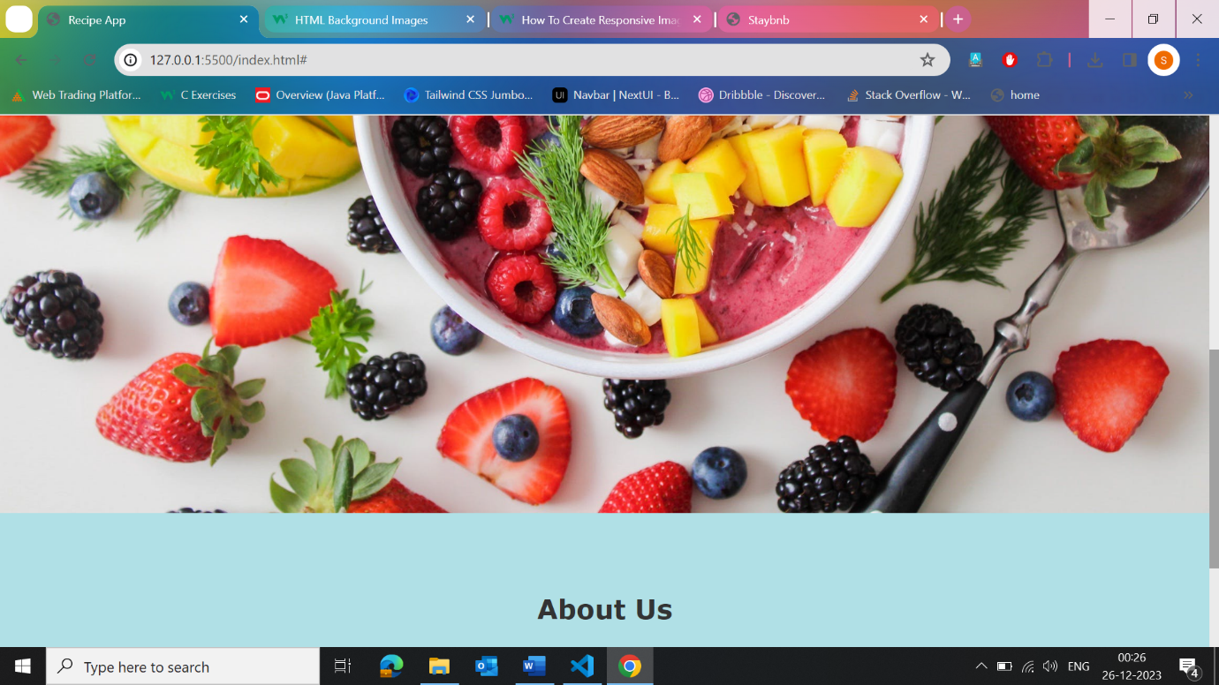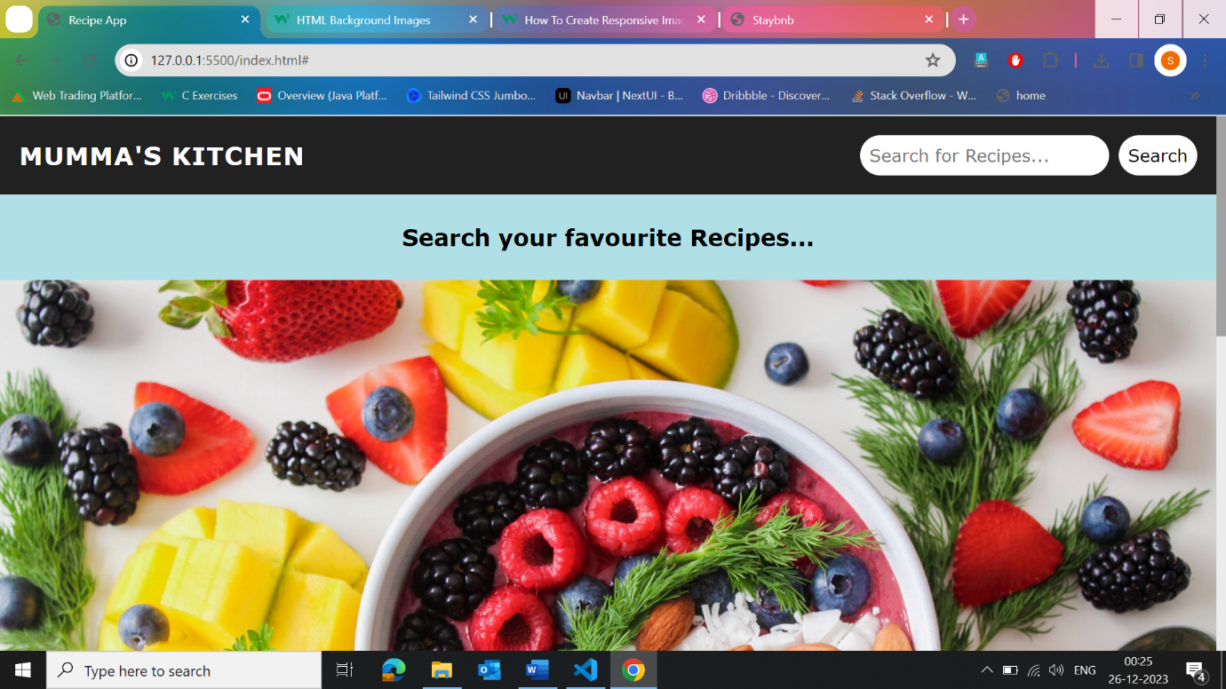

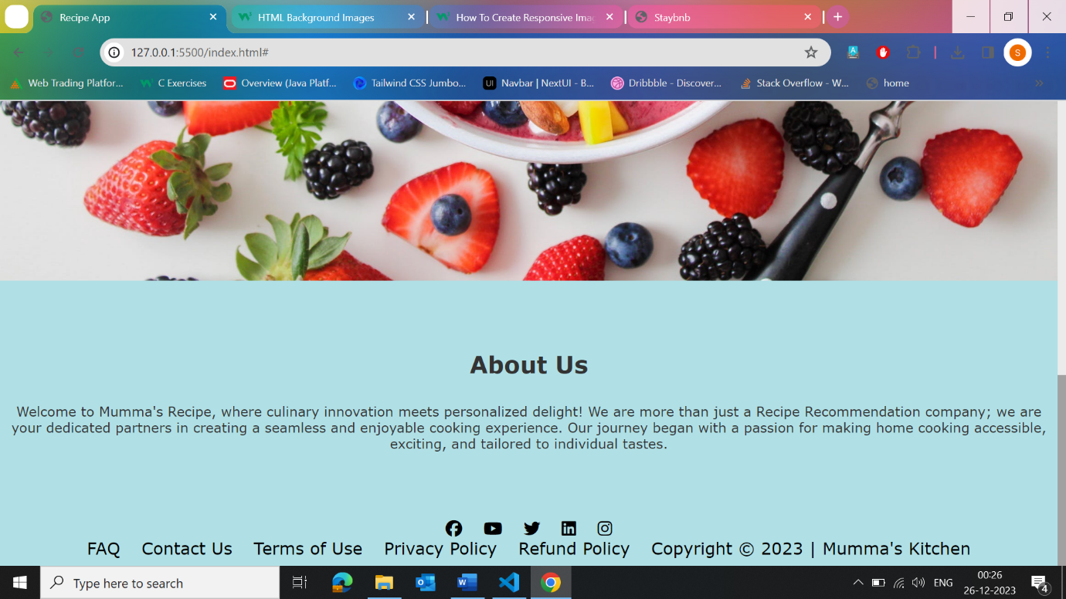

**Image – 2**

In this section after searching a particular recipe when we click on recipe, it shows its ingredients and instructions to make that recipe.

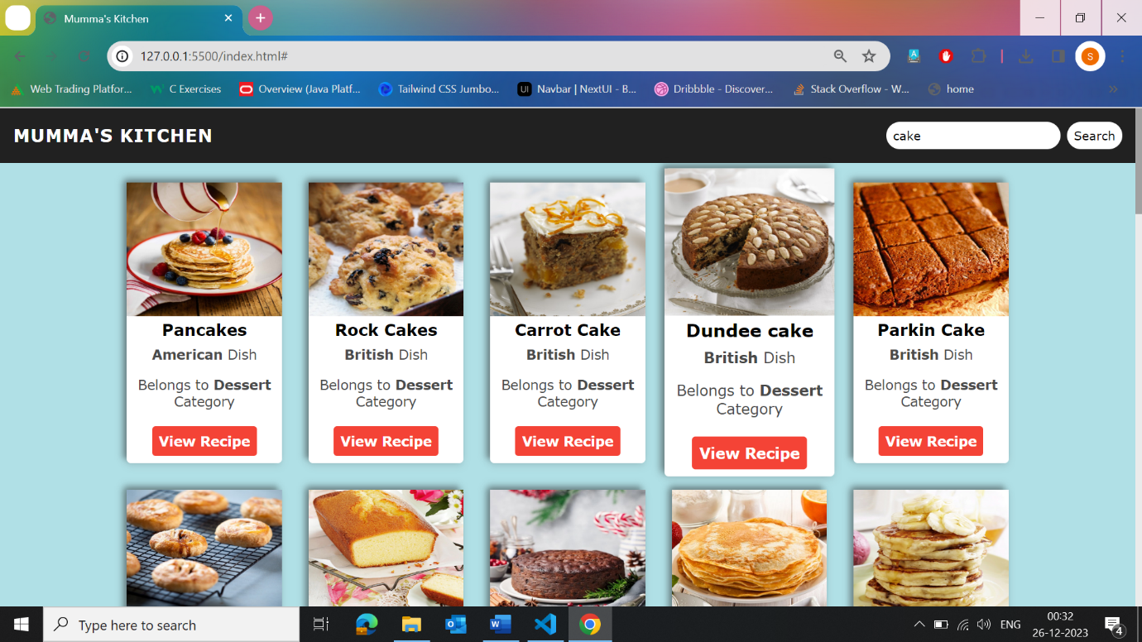

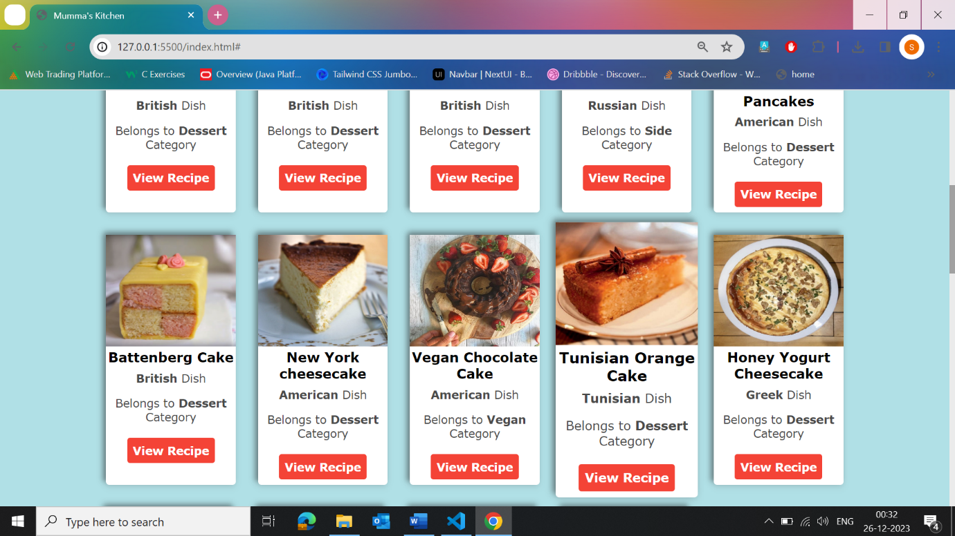

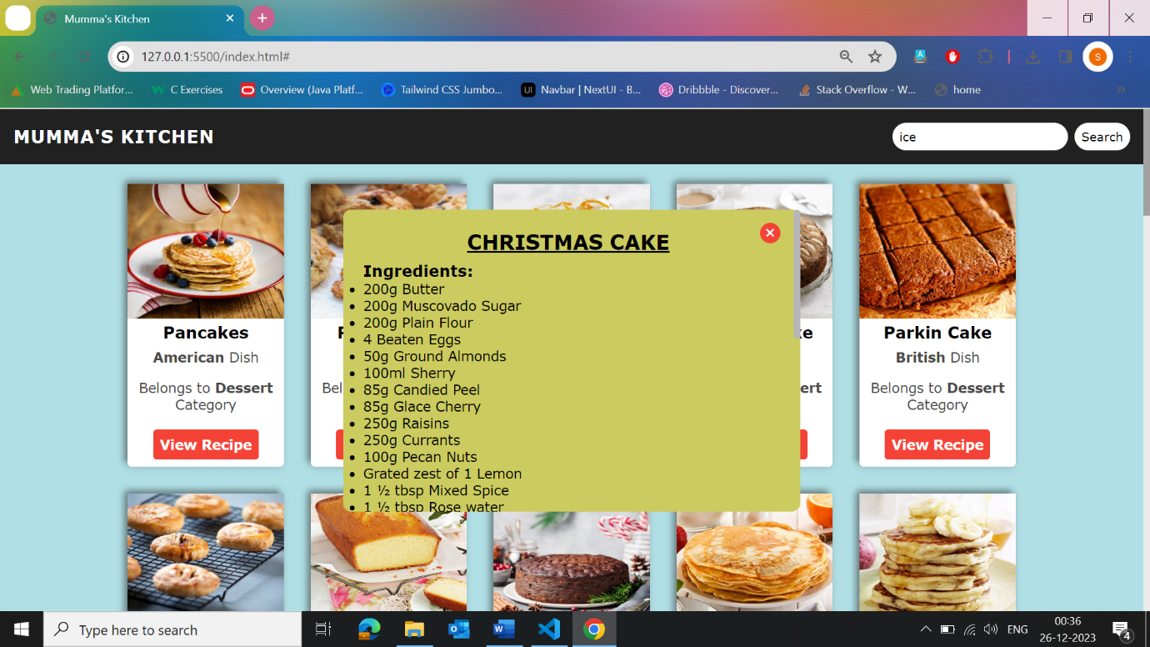

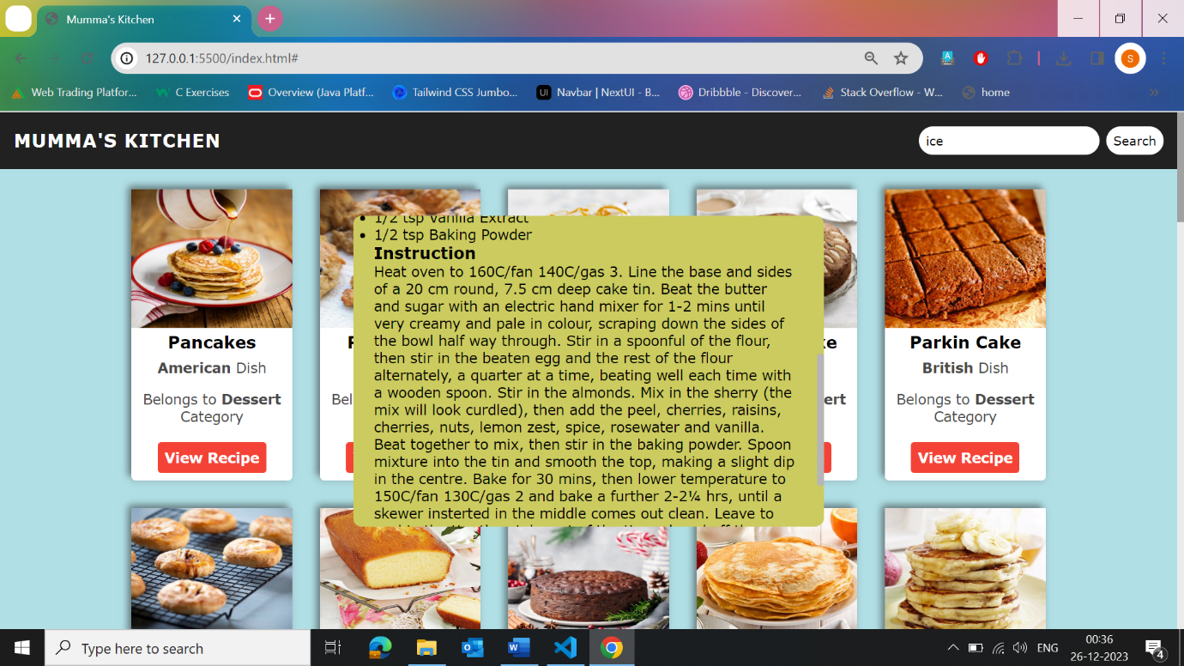

**Image - 3**

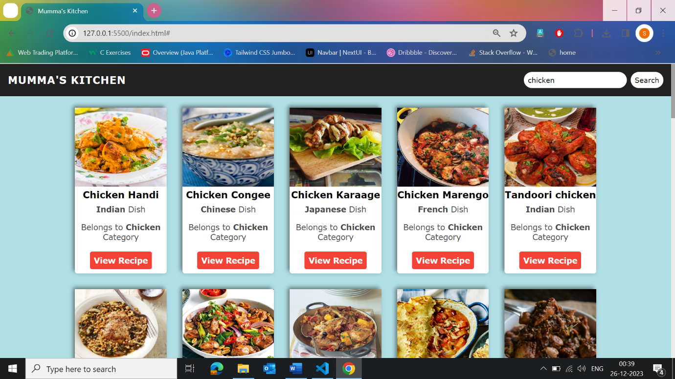In this section , **MBA** in which there are different courses. After clicking on the course video gets started.

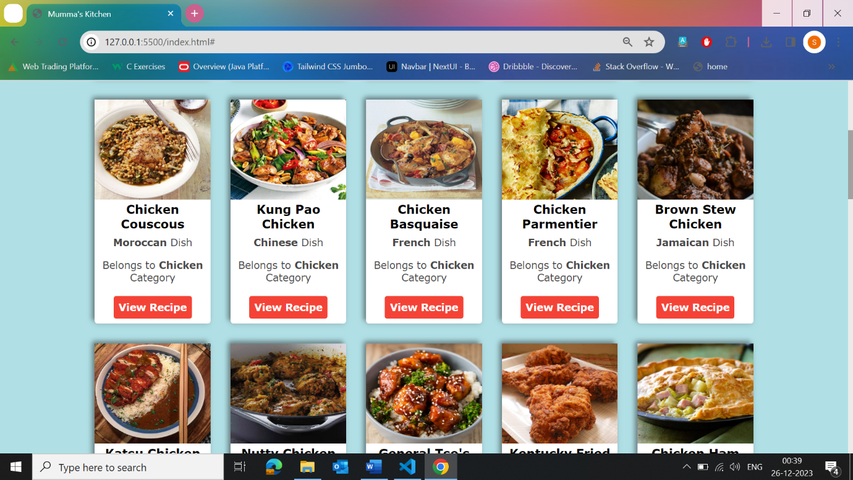

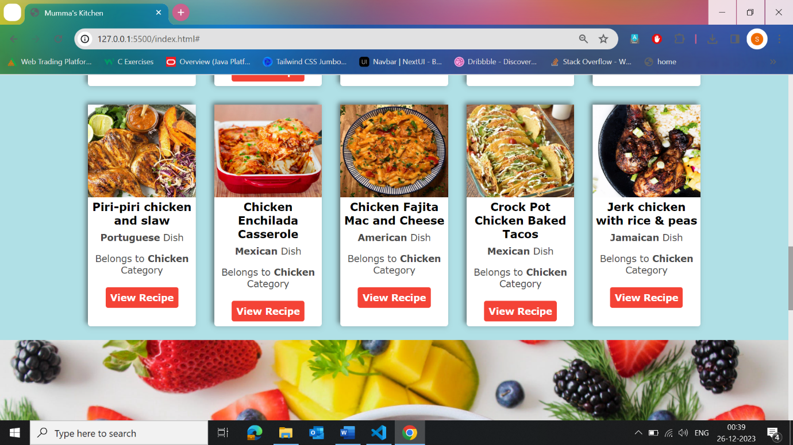

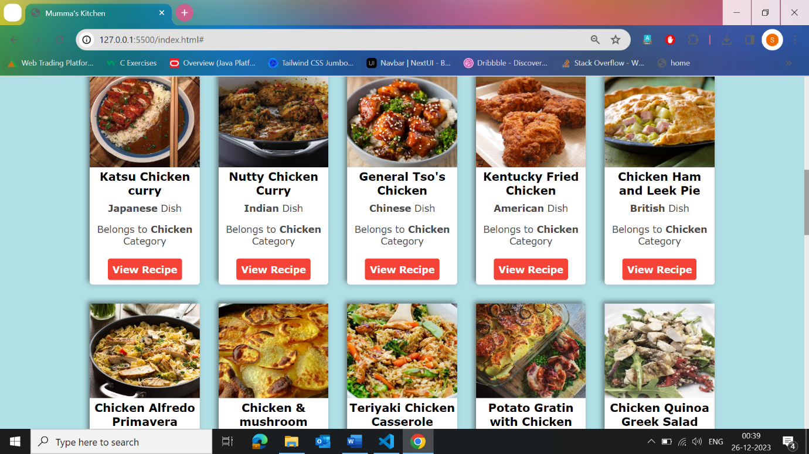

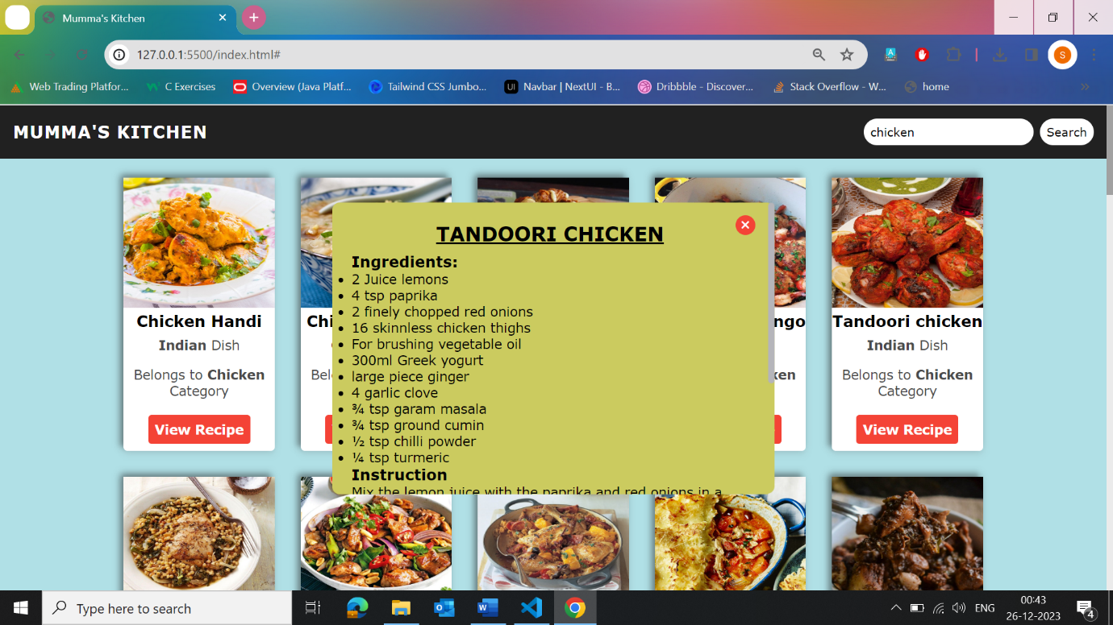

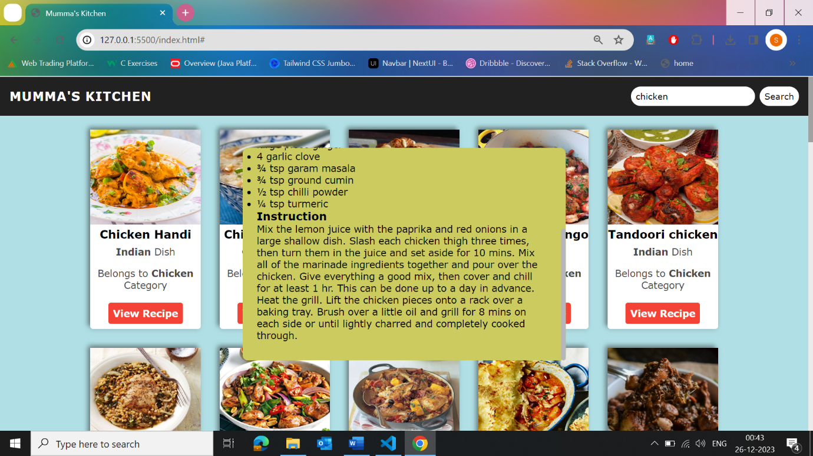

**Image – 4**

If search box is blank and when we click on search box then it shows **“Type the meal in Search box”.**

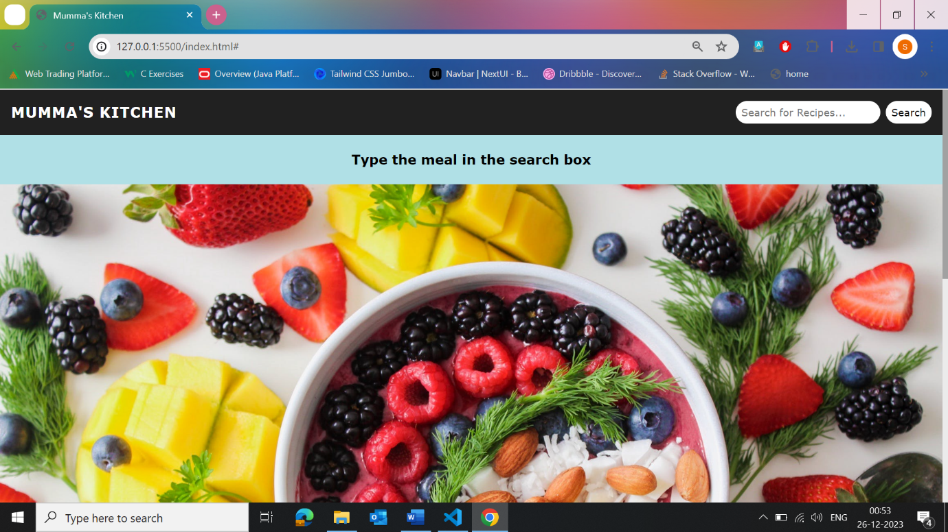

**Image – 5**

When we click on any recipe then pop-up box get displayed on the screen.



**Conclusion**

In conclusion, the recipe app, built with HTML, CSS, JavaScript, and API integration, offers a user-friendly experience with responsive design, robust search features, and interactive elements. Social integration and analytics enhance community engagement, while security measures and legal considerations ensure a trustworthy platform. Regular maintenance, user feedback, and continuous improvement contribute to a dynamic and reliable app. With potential for monetization and partnerships, the recipe app becomes a versatile and valuable resource for culinary enthusiasts, combining functionality with a sense of community.

Top of Form